Homework 1

SDEV Login Application Test Cases

Michael Harrison

Test Table

|  |  |  |  |  |
| --- | --- | --- | --- | --- |
| Test # | Input Text | Expected Result | Actual Result | Pass / Fail |
| 1 | Username: bob  Password: dog | Incorrect Login (logged) | Incorrect username and password | Pass |
| 2 | Username: James  Password: Johnson | Incorrect Login (logged) | Incorrect username and password | Pass |
| 3 | Username: Jim  Password: Beam | Incorrect Login  (logged) | Incorrect username and password | Pass |
| 4 | Username: admin  Password: password | Successful Login  (logged) | Successful Login | Pass |
| 5 | Username: biscuit  Password: jam  Select “Clear Fields” | Fields are cleared | Fields are cleared | Pass |
| 6 | All Logins are logged to c:\temp\test_log.txt | Logs each login with time and date | Each login is logged with time and date | Pass |

Test # 1:

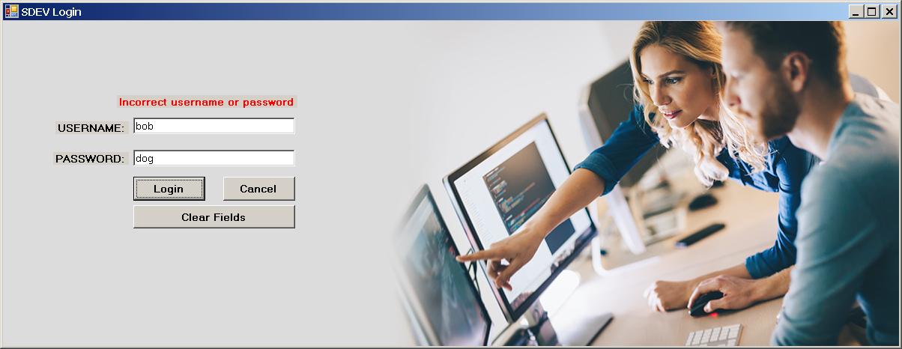

Test #2:

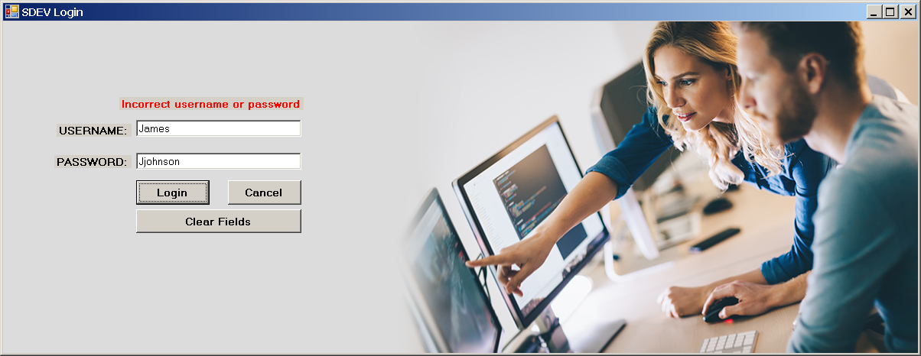

Test #3:

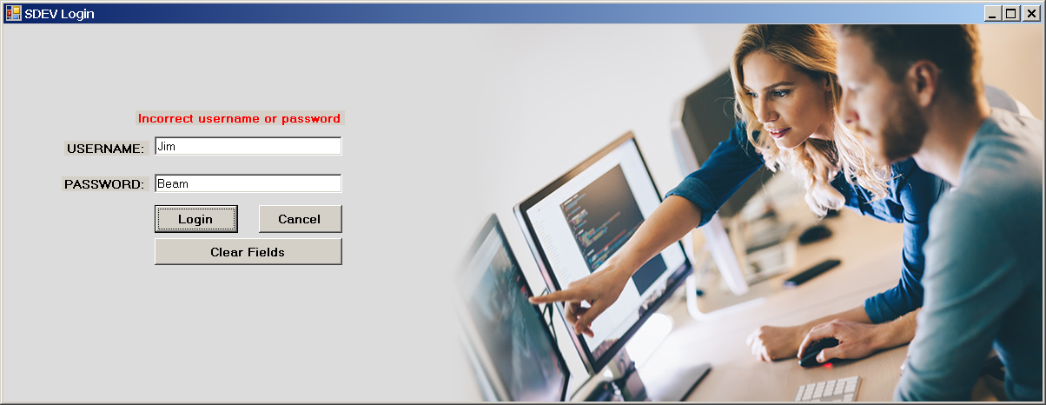

Test #4:

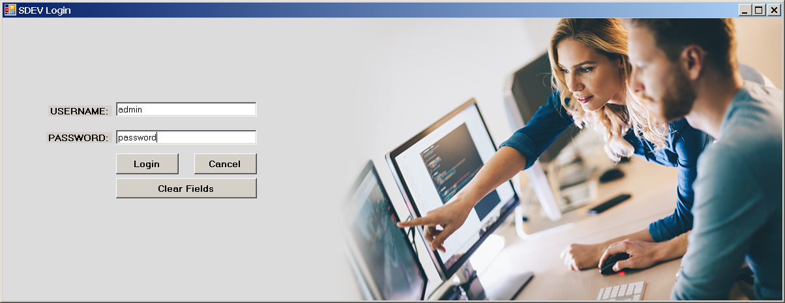

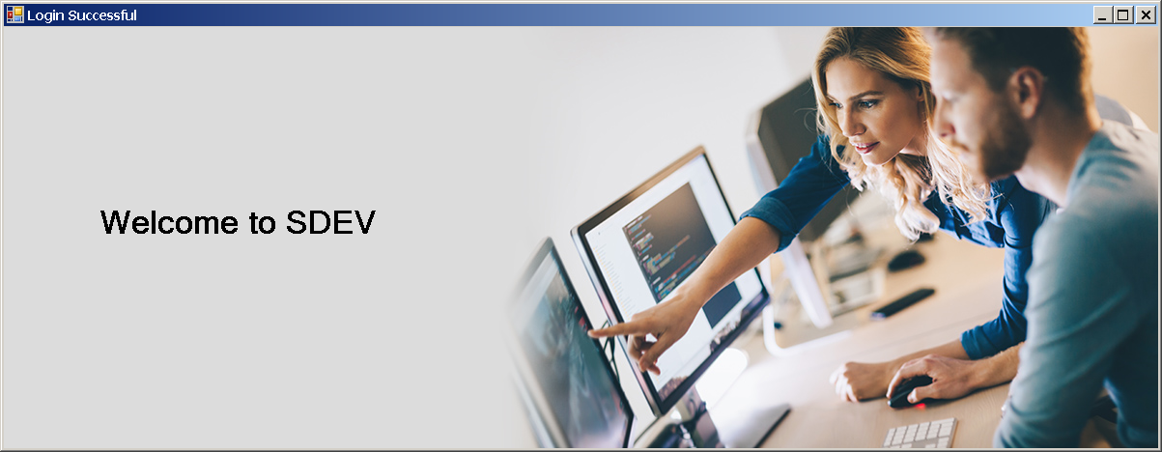

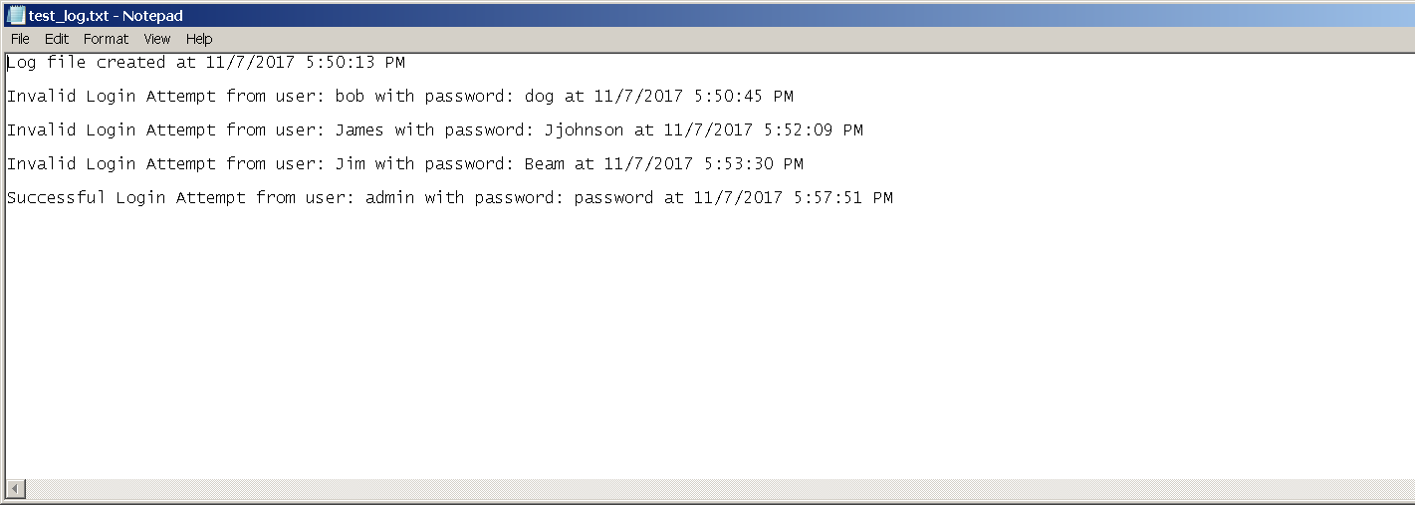

Test #5:

